File IO Day 1 Lecture

Objectives

* Read from a text file into a list
* Write a string into a file
* Use the paths, file, filesystem, filewriter objects

# Setup

* Create a new java project – keep the main
* Create a directory on the C: drive named data
  + Just using to demonstrate paths and variables
* Download the temperature.txt file from BB weekly resources
  + Copy this file into the c:\data folder
  + A file with 1000 random temperatures
  + Mockaroo.com

# Theory

* File IO is designed to create persistent storage
* Can write/read files
* Path class
  + Provides information about location, file creation, size…
* File class
  + Allows you to manipulate the file on disk
* FileSystem class
  + Allows access to the disk and file systems

# Code – file information

* Add these variables  
  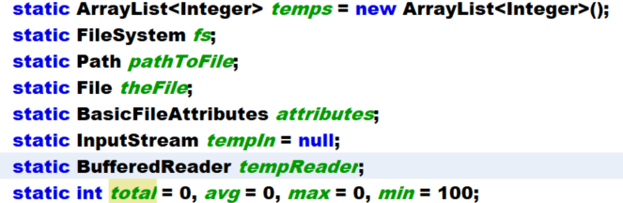
* These imports  
  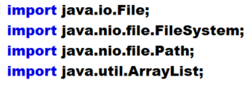
* Create this method to connect to the file  
  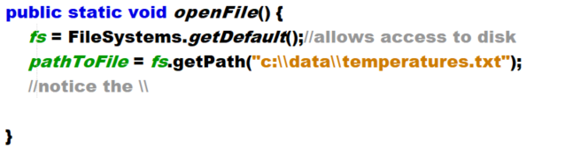
* Call in main
* Determine basic information about the path  
  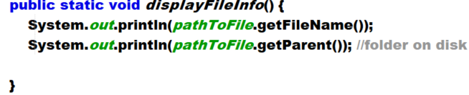
* Call in main
* Get file attributes – add to displayFileInfo  
  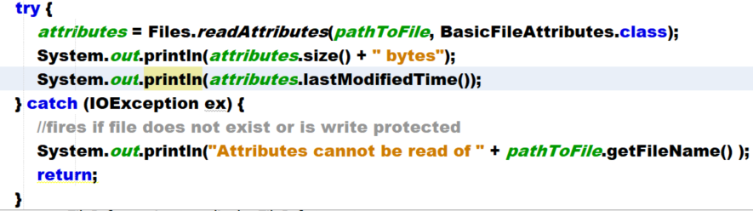

# Code – Read the file into memory

Open the file

* We will read in using an InputStream
  + Requires the path to the file
* Add this to openFile  
  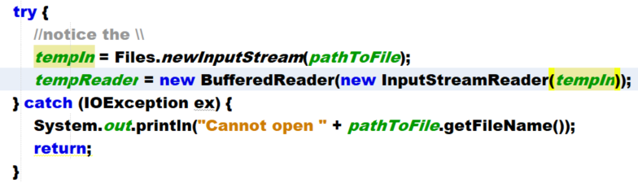
* newInputStream connects to the file allowing it to be opened
* BufferedReader reads the file
  + Allows access to the file one line at a time
  + Caches the lines for faster reading
  + If either fail, then an exception is thrown and the program dies

Read the file

* We will read the file into the ArrayList and do some math as we do so.
* Start reading the file  
  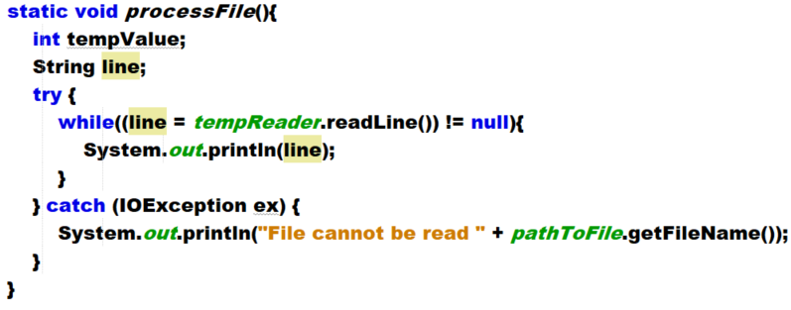
* Call in main
* Run, verify that the lines output
* Process the file
  + Remove the output in the while
  + Replace with this  
    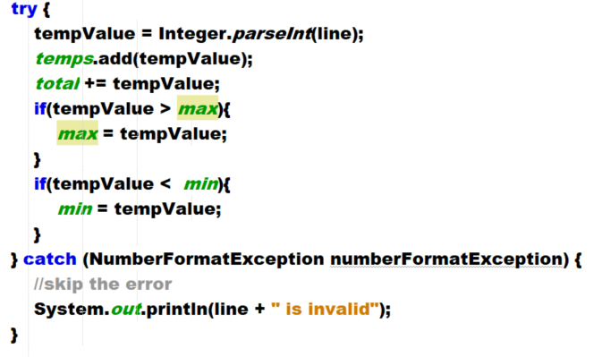
* Add to main  
  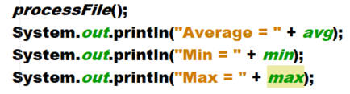
* Close the file at the end of main
* 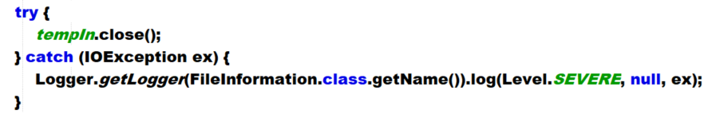

Write a file

In this section we will write a file to disk. You will ask the for a first name, last name. The program will write out the username and password to a file.

Writing to a file will overwrite it by default. Be careful. Options page 684 (look at this)

* Create a new main called writeFile.
* Add these variables  
  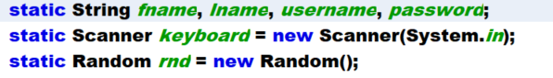
* Create this method  
  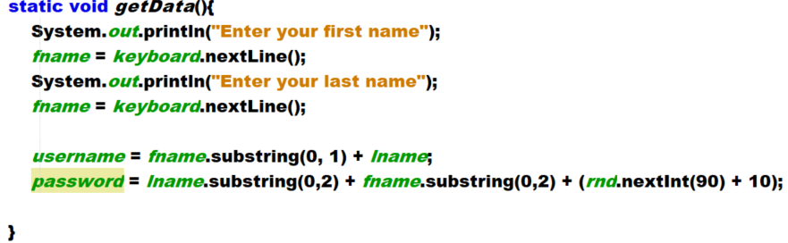
* Call in main
* Create this method to write out to file  
  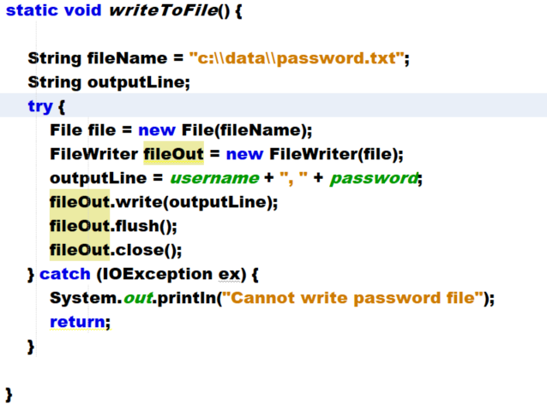
* Run multiple times showing overwrite
* Delete the password file, and modify as shown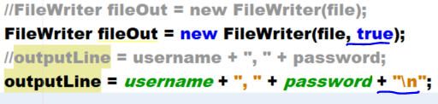
* The true turns the writer into an append, and adds to the end of the file, \n ensures a newline